TEKAMUK Traditional  GATHERINg  MESA GRANDE  July 30, 2016  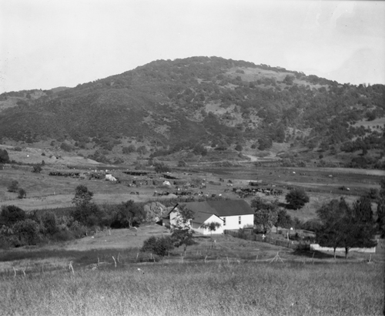  Location:  @Tekamuk traditional village & Fiesta Grounds  (200 yards down ANGEL MTN RD OFF MESA GRANDE RD)  Children’s Activities-Raffles-Prizes throughout the day |  | welcoming ceremony @10am  horseshoe tournament @ 12PM  Registration @ 10AM  $ 500 + Buy-in  Bring your own partner  REz Vs. Rez  tug-o-war @3PM  6 person team  Social bird singing  and dancing  Peon at dusK  Mens Pot $2,000 + Buy-in  Womens Pot $1,200  Boys & Girls Pot $400  for general and vendor information contact:  gabE kitchen  @ (760) 855-3486  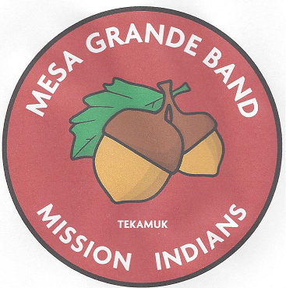
~This is a alcohol & drug free event~

